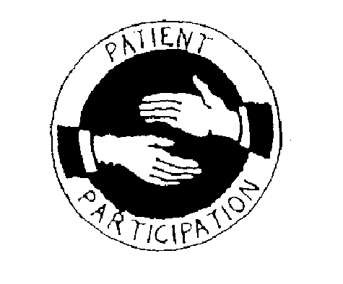
BARGOOSE
Dr Margaret E Glaze & Partners Patient Participation Group

We are seeking a small group of people who can be contacted by e-mail to give their views on proposed changes and improvements to the services we provide. The contact would be once or at most twice a year over the next two years.
If you are happy for us to contact you by e-mail please leave your details below and hand this form back to reception, a Bargoose representative or post in the ‘secure’ Suggestions Box.
Name: E-mail Postcode
This additional information will help to make sure we try to speak to a representative sample of the patients that are registered at the Practice.
Are you? Male Female Please tick a box

Age group | Under 25
 | 25 - 50
 | 51 - 75
 | Over 75
Please tick a box
To help us ensure our contact list is representative of our local community please indicate which of the following ethnic background you would most closely identify with?
Please tick a box
How would you describe how often you come to the Practice?
White or White British
Asian or Asian British
Black or Black British
Chinese or other ethnic group
Please tick a box
Regularly
Occasionally
Very rarely
The information you supply us will be used lawfully, in accordance with the Data Protection Act 1998. The Data Protection Act 1998 gives you the right to know what information is held about you, and sets out rules to make sure that this information is handled properly.
Thank you

